**Exercise 2.a. – Creation of Web Page using HTML**

**Name:** Badri MSV **Roll No:** 195002017

**Subject:** UIT1611 – Web Programming Lab **Faculty:** Dr. S. Sasirekha

**Date:** 22.03.2022

**Aim:**

To create a Web Page using HTML.

**Description of Pages:**

* home.html
  + Initial Page on Opening of Application
  + Will provide Login Functionality
  + Will forward to other pages
* time.html
  + First page after logging in
  + Will display time table to the user
  + Has hyperlinks to reminders and logout
  + Lists faculty and Subject Code
* rem.html
  + Will provide a form to enter details for a reminder
  + Can reset or submit the form
* f1. html
  + Page purely to define frame sets and frame sources
* titlebar.html
  + Contains hyperlinks to other pages, serves as a navigation bar
* contents.html
  + Serves as a table of contents
  + Contains a PNG Time Table that links a subject to its LMS Page

**Code:**

home.html

<!doctype html>

<html>

<head>

    <link rel="stylesheet" href="style.css">

    <title>

        Login Page

    </title>

    <style>

        body,

        html {

            height: 100%;

        }

        * {

            box-sizing: border-box;

        }

        #loginbox {

            width: 700px;

            border: 3px dotted bisque;

            padding: 50px;

            margin-left: 220px;

            font-size: 25px;

        }

        label{

            color:blue

        }

    </style>

</head>

<body>

    <div class="bg-image"></div>

    <div class="bg-text">

        <h1 style="text-align: center; font-family: 'Courier New', Courier, monospace; color:chocolate; font-size:50px">

            Time Table Reminder System

        </h1>

        <hr />

        <form action="f1.html" target="_top" id="loginbox">

            <h2 style="color: lime">Login</h2>

            <label for="user">Username:</label>

            <input type="text" name="user" id="user"> <br />

            <label for="pass">Password:</label>

            <input type="password" name="pass" id="pass"> <br />

            <input type="submit">

        </form>

        <hr />

    </div>

</body>

</html>

time.html

<!doctype html>

<html lang="en">

    <head>

        <base target="_top">

        <meta charset="UTF-8">

        <meta name="description" content="Time Table Reminder System">

        <meta name="keywords" content="HTML">

        <meta name="author" content="Badri MSV">

        <meta name="viewport" content="width=device-width, initial-scale=1.0">

    </head>

    <title>

        Time Table Page

    </title>

    <body>

        <h1>Time Table Reminder System</h1>

        <hr />

        <p>

            <a href="f1.html">Time Table</a> ||

            <a href="rem.html">Reminders</a> ||

            <a href="home.html">Log Out</a>

        </p>

        <hr />

        <h2><a id="timetable">Time Table</a></h2>

        <table border="2" cellpadding="10" cellspacing="5" span>

            <tr bgcolor="grey">

                <th>Day/Period</th>

                <th>1</th><th>2</th><th>3</th><th>4</th><th>5</th><th>6</th><th>7</th><th>8</th>

            </tr>

            <tr>

                <th bgcolor="grey">Monday</th>

                <td>Principles of Compiler Design</td>

                <td>Big Data Engineering</td>

                <td bgcolor="green" rowspan="3">Break</td>

                <td>Open Elective</td>

                <td bgcolor="green" rowspan="4">Lunch</td>

                <td>Web Programming</td>

                <td colspan="2">Interpersonal Skills/Listening and Speaking</td>

            </tr>

            <tr>

                <th bgcolor="grey">Tuesday</th>

                <td>Web Programming</td>

                <td>Machine Learning</td>

                <td>Principles of Compiler Design</td>

                <td colspan="3">Web Programming Lab<img src="wp.png" height="40" width ="45" usemap="#map1"></td>

                <map name="map1">

                    <area shape="circle" coords="20,20,15" href="https://lms.ssn.edu.in/course/view.php?id=4985">

                </map>

            </tr>

            <tr>

                <th bgcolor="grey">Wednesday</th>

                <td>Open Elective</td>

                <td>Principles of Compiler Design</td>

                <td>Machine Learning</td>

                <td>Professional Elective</td>

                <td colspan="2">PCD/ML - Lab</td>

            </tr>

            <tr>

                <th bgcolor="grey">Thursday</th>

                <td>Professional Elective</td>

                <td colspan="3">PCD/ML - Lab</td>

                <td>Big Data Engineering</td>

                <td>Mentor</td>

            </tr>

            <tr>

                <th bgcolor="grey">Friday</th>

            </tr>

        </table>

        <hr />

        <h3>List of subjects and faculty:</h3>

        <ol type="1">

            <li>

                UIT1601

                <ul type="disc">

                    <li>Principles of Compiler Design</li>

                    <li>Josephine Julina</li>

                </ul>

            </li>

            <li>

                UIT1602

                <ul type="disc">

                    <li>Web Progamming</li>

                    <li>S Sasirekha</li>

                </ul>

            </li>

            <li>

                UIT1603

                <ul type="disc">

                    <li>Big Data Engineering</li>

                    <li>K S Gayathri</li>

                </ul>

            </li>

            <li>

                UIT1604

                <ul type="disc">

                    <li>Machine Learning Fundamentals</li>

                    <li>A Shahina</li>

                </ul>

            </li>

            <li>

                <a id="4">UIT1611</a>

                <ul type="disc">

                    <li>Web Programming Lab</li>

                    <li>S Sasirekha</li>

                </ul>

            </li>

        </ol>

        <hr />

    </body>

</html>

rem.html

<!doctype html>

<html lang="en">

    <head>

        <meta charset="UTF-8">

        <meta name="description" content="Time Table Reminder System">

        <meta name="keywords" content="HTML">

        <meta name="author" content="Badri MSV">

        <meta name="viewport" content="width=device-width, initial-scale=1.0">

    </head>

    <title>

        Reminders Page

    </title>

    <body>

        <h1>Time Table Reminder System</h1>

        <hr />

        <p>

            <a href="f1.html">Time Table</a> ||

            <a href="rem.html">Reminders</a> ||

            <a href="home.html">Log Out</a>

        </p>

        <hr />

        <h2>Reminders</h2>

        <form action="home.html">

            <label for="remname">Reminder Title:</label>

            <input type="text" name="remname" id="remname"> <br />

            <label for="remtype">Reminder Type:</label>

            <select name="remtype" id="remtype" size="1">

                <option>Personal

                <option>Course

                <option>Department

                <option>Homework

            </select> <br />

            <label for="remdetails">Reminder Details:</label>

            <input type="text-area" name="remdetails" id="remdetails"> <br />

            <p>Will you require email notification?</p>

            <input type="radio" name="remyesno" id="remyes">

            <label for="remyes">Yes</label>

            <input type="radio" name="remyesno" id="remyno">

            <label for="remno">No</label> <br />

            <input type="checkbox" name="urgent" id="urgent">

            <label for="urgent">Is it Urgent?</label><br />

            <input type="reset"><input type="submit">

        </form>

        <hr>

    </body>

</html>

f1.html

<html>

    <frameset rows="25%,*">

        <frame src="titlebar.html">

        <frameset cols="40%,*">

            <frame src="contents.html">

            <frame src="time.html" name="time">

        </frameset>

    </frameset>

</html>

titlebar.html

<!doctype html>

<html lang="en">

    <head>

        <base target="_top">

        <meta charset="UTF-8">

        <meta name="description" content="Time Table Reminder System">

        <meta name="keywords" content="HTML">

        <meta name="author" content="Badri MSV">

        <meta name="viewport" content="width=device-width, initial-scale=1.0">

    </head>

    <title>

        Time Table Page

    </title>

    <body>

        <h1>Time Table Reminder System</h1>

        <hr />

        <p>

            <a href="f1.html">Time Table</a> ||

            <a href="rem.html">Reminders</a> ||

            <a href="home.html">Log Out</a>

        </p>

        <hr />

    </body>

</html>

contents.html

<!doctype html>

<html>

    <body>

        <p>

            <h2>Internal Hyperlinking:</h2>

            <a href="time.html#timetable" target="time">Go to time table</a>

            <a href="time.html#4" target="time">UIT1611</a>

        </p>

        <h1>Completed Time Table as PNG</h1>

        <img src="tt.png" usemap="#map2">

        <map name="map2">

            <area shape="rect" coords="73,73,155,120" href="https://lms.ssn.edu.in/course/view.php?id=4975" alt="PCD" target="_top">

            <area shape="poly" coords="156,122,239,122,240,167,339,168,339,214,241,214,241,168,156,166"

            href="https://lms.ssn.edu.in/course/view.php?id=4981" alt="math" target="_top">

        </map>

        <hr />

    </body>

</html>

**Output:**

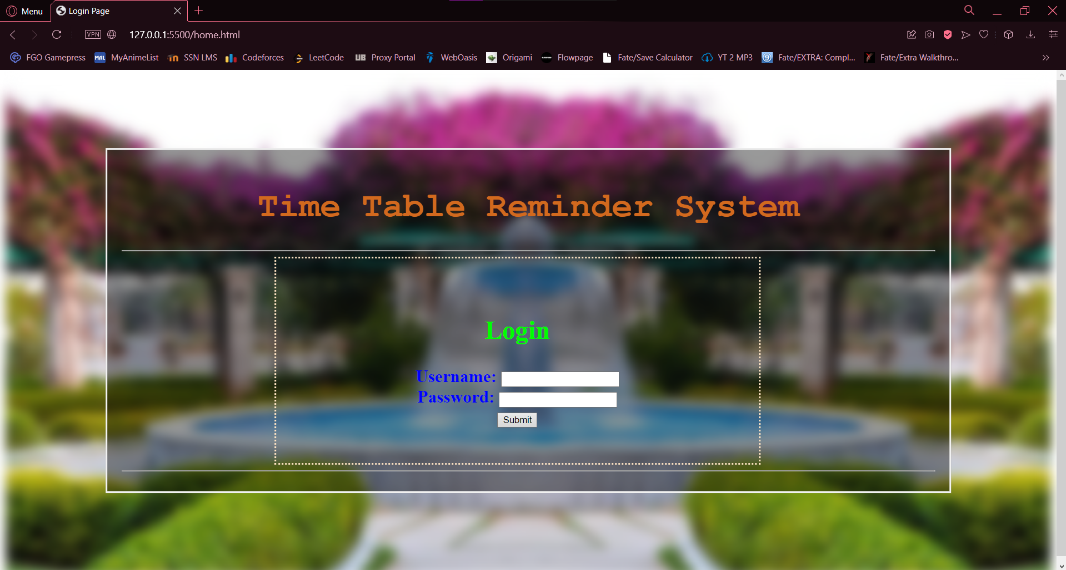

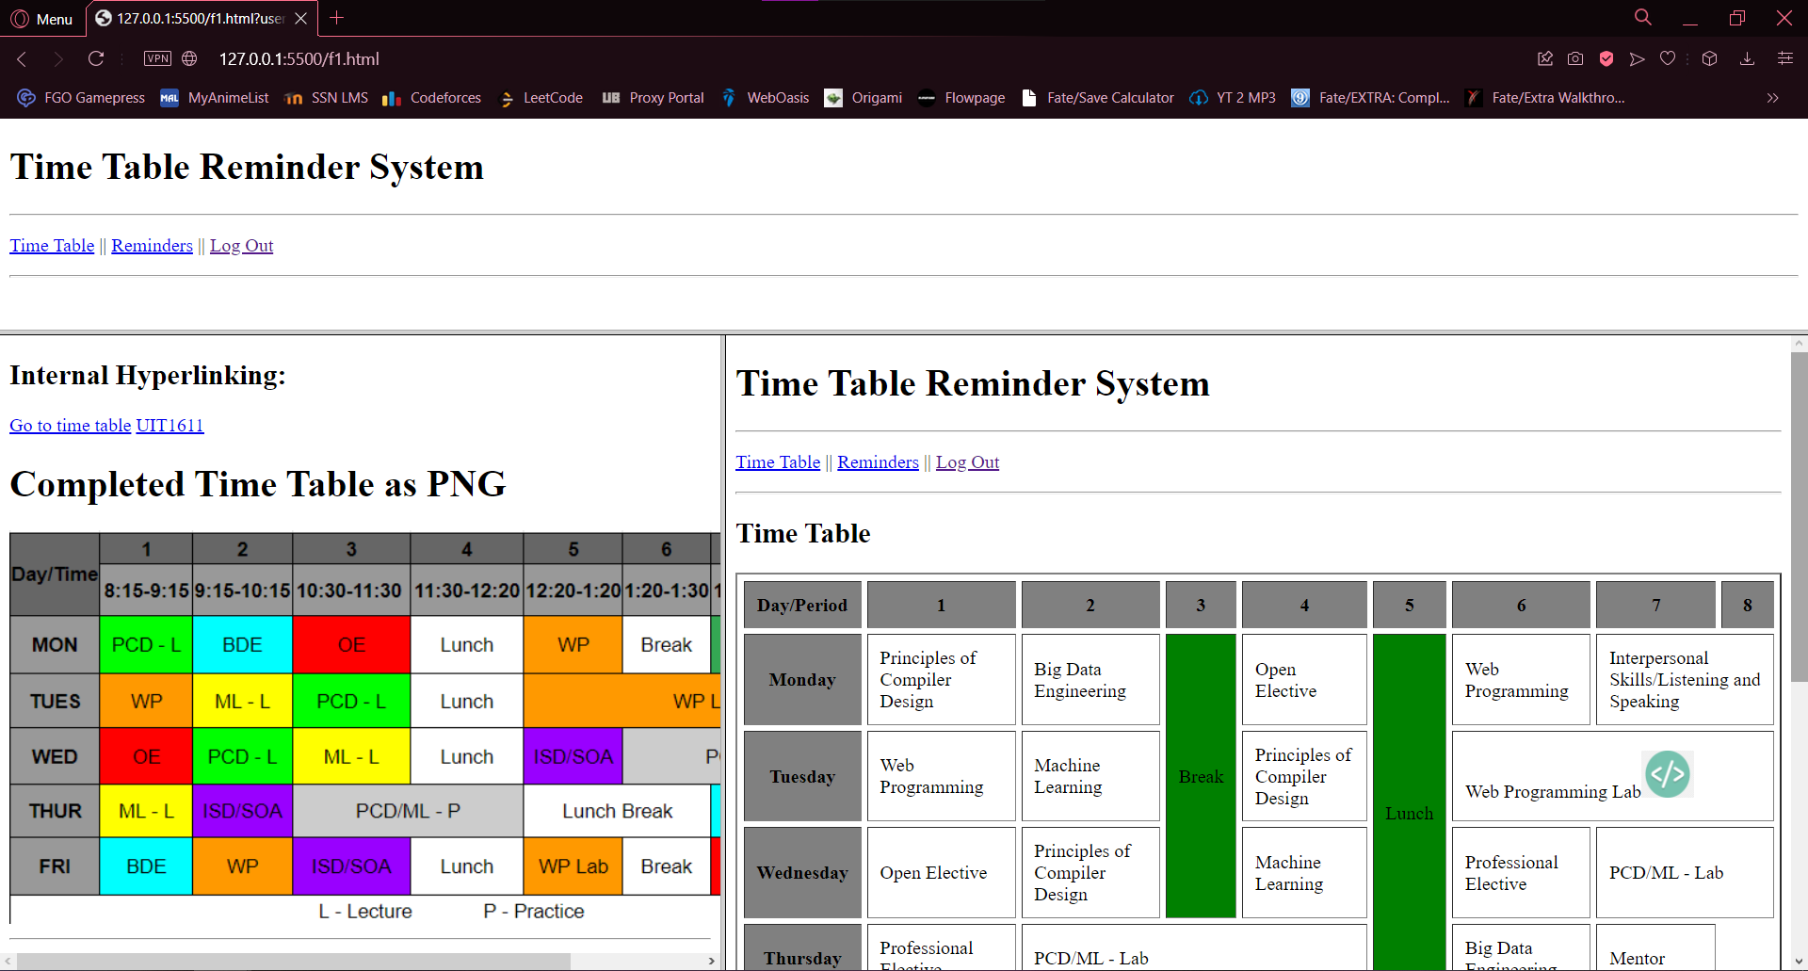

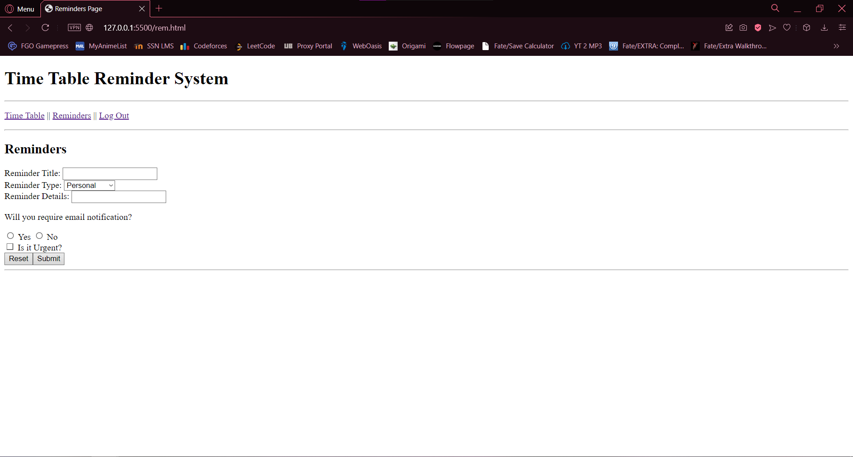

**Result:**

Thus, a set of HTML Pages tailored to the Time Table Reminder System were created using all the given set of tags.